Steps and Guidelines to run the Program:

1. Open the file in power shell.

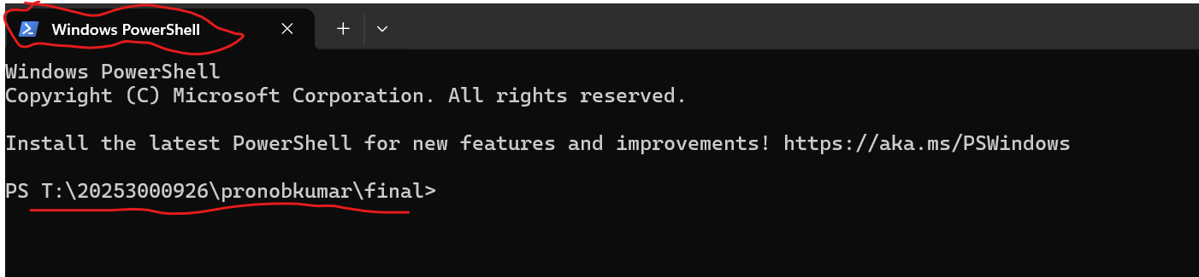

1. Run the command “node server.js”

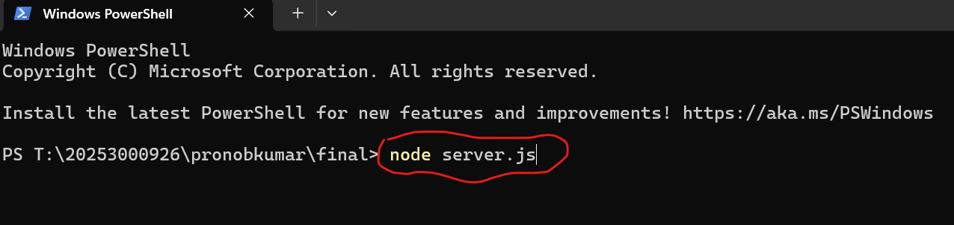

1. After a couple of seconds, you will see “Server is running on <http://localhost:3000>”. If localhost:3000 is busy due to some other websites, please turn that off or change the localhost number in the server.js code. It is in line 143.

1. After the local host is running, go to a browser and search “http://localhost:3000” (you might need to change the local host number if you changed it on the server.js code.)

1. Now you can log in to the website by registering your name and password. Or you can use the built-in password from here.

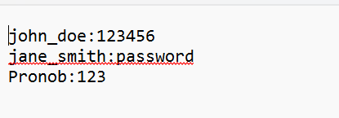

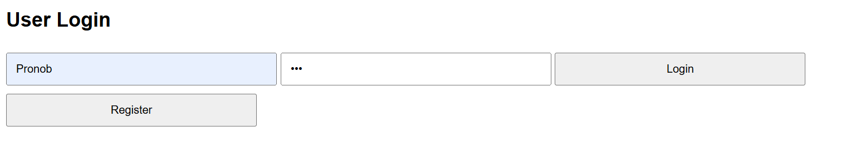

1. After login you can search for tutors or be a tutor on the “Tutors” option page.

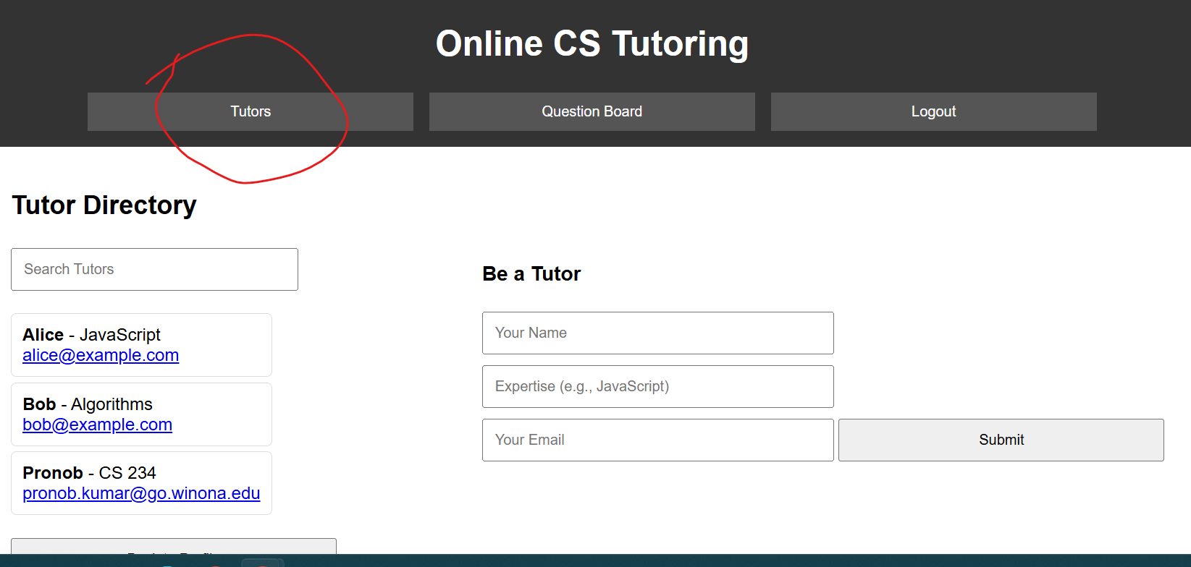

1. If you want to ask or answer questions, go to the “Question Board” option.

